**Department of Computer Science and Engineering  
The University of Texas at Arlington**



**User Manual**

Team: Team Argus

Project: PixelSense Secure Transfer - Lynx

Team Members:   
*Shamikul Amin*

*Brandon Deen*

*Brian Hasty*

*Keyur Patel*

*Seth Skocelas*

**Last Updated: 5/15/2015 3:32 PM**

Table of Contents

Document Revision History 3

1. Product Concept 4

2. Instructions 5

# Document Revision History

|  |  |  |  |
| --- | --- | --- | --- |
| **Revision Number** | **Revision Date** | **Description** | **Rationale** |
| 0.5 | 10/8/2014 | Initial Draft | Needed to be created |

# 1. Product Concept

The end result of the PixelSense Transfer Project was a blackjack game that can be played using the following items:

* Samsung SUR-40
* Android Tablet
* Lynx Device
* Visual Studio 2010

The BlackJack game follows the basic rules of BlackJack. The user will receive a hand of cards and an initial pot of 10,000 chips. The objective is to remain under 21 point value for cards before the dealer busts, or to have a card amount close to 21. Once the user receives his hand, the user needs to select the bet amount they want to wager by selecting it on the Android screen. Once the bet is place, the user needs to select whether or not they want to stay or hit based on what card value amount they have in their hand. This process is repeated until either the user or the dealer busts by exceeding the card amount.

Please note that whenever an action occurs, the update button must be pressed in order for changes to occur on both the tablet and the SUR-40.

Below is a picture guide showing how to run our software. Please run it by opening the solution in Visual Studio and compiling the PixelSense software. Also, installation of the Lynx App.apk will need to occur on any tablet you will want to use.

# 2. Instructions

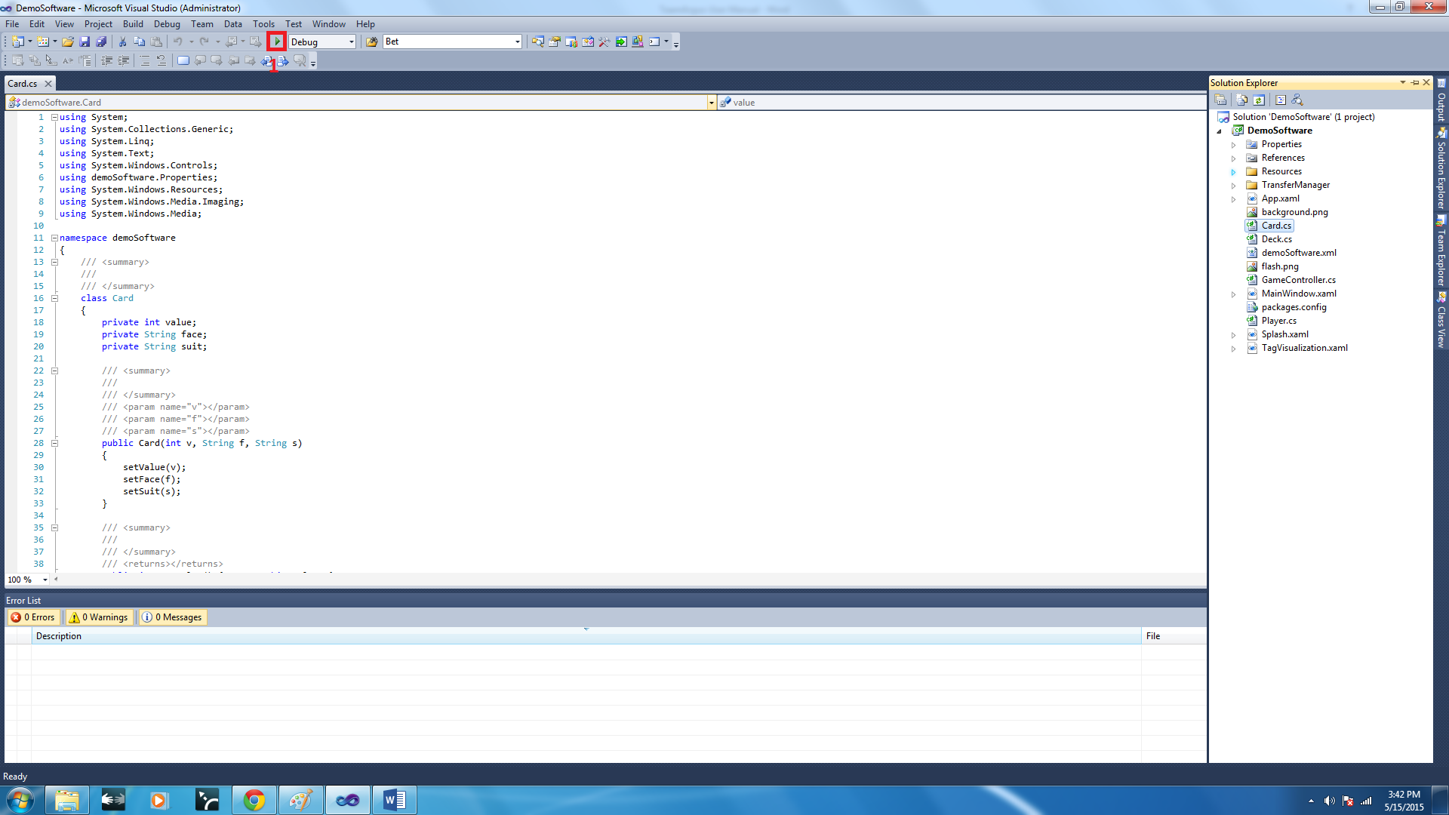

To run the PixelSense application, run the .suo file provided and compile the program by clicking the green arrow highlighted above.

If the Lynx App is not installed on the Android Tablet you want to use, please install the .apk file provided using the standard APK USB installation method.

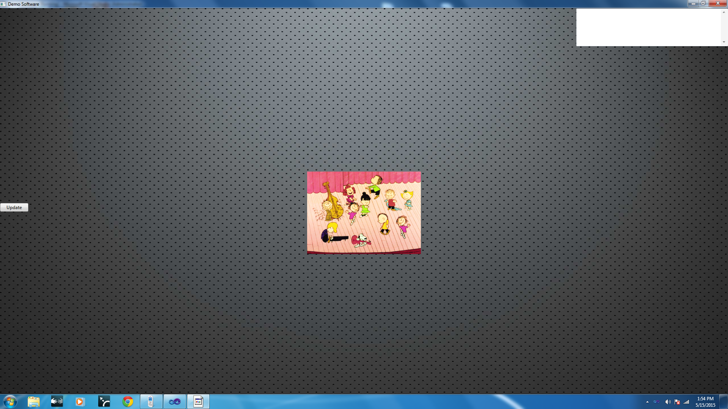

This is the initial load screen for the Lynx device. To proceed to the BlackJack application, place a valid Lynx device on the table. This will cause the BlackJack application to load on the screen and you can begin playing the game.

In order to operate any functions of the game, the Lynx app must be operating on the Android Tablet connected to the Lynx device.

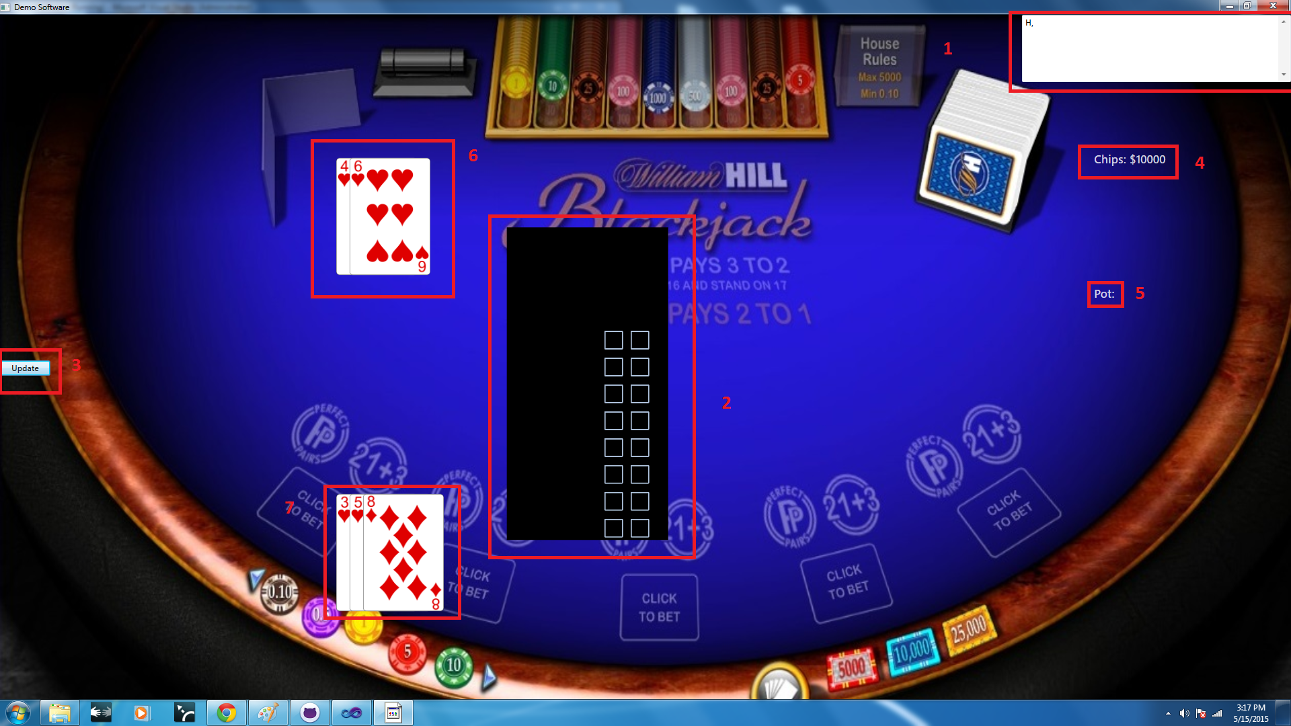

This is the main game screen for our BlackJack application on the SUR-40. From here you can see all the actions that occur within the game. Each of the interactions are outlined in red. They are detailed by number in the list below.

1. Console Output: This displays any game messages that occur during the game, such as whether the dealer/player wins or bust, and any chip count information. If the system is unable to interpret any data from the Lynx device, the console will display “Bad Read” and the information will need to be sent again.
2. Lynx Outline: This outline will appear anywhere the Lynx device is displayed. This allows the area to read and write data to the Lynx device. Please note that we were unable to get this grid to orient correctly whenever the device is rotated, so reading/writing will only work if the device is place to completely cover the grid by placing the device straight up with the tag closest to the top part of the table. Essentially, the device needs to be placed to match the grid on the screenshot.
3. Update Button: Due to limitation of our current code, anytime a transaction occurs between the Lynx device and the SUR-40, the update button must be pressed in order to reflect this change on the device.
4. Chip Count: This is the money amount for the chips the player currently has.
5. Pot: This shows the current bet amount the user is placing for the current round of BlackJack.
6. Dealer Cards: This displays the cards the dealer currently has.
7. Player Cards: This displays the cards the player currently has.

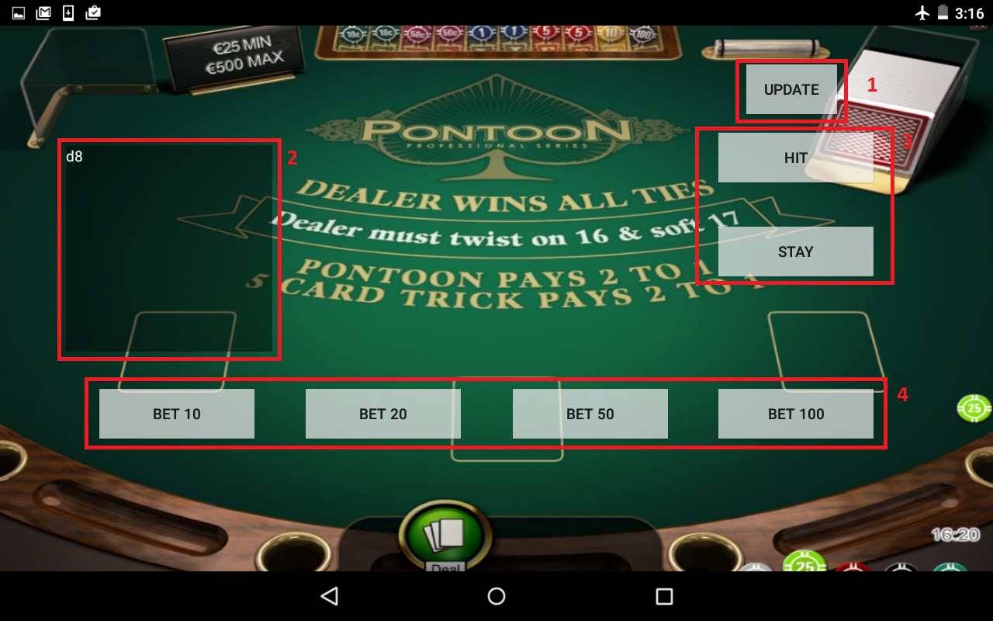

This is the main screen for our BlackJack application on the Android Tablet. From here you can see all the actions that occur within the game. Each of the interactions are outlined in red. They are detailed by number in the list below.

1. Update Button: Due to limitation of our current code, anytime a transaction occurs between the Lynx device and the tablet (whenever data is read by the Lynx device), the update button must be pressed in order to reflect this change on the device.
2. Console Output: This displays any information from the table read by the Lynx device. If the system is unable to interpret any data from the Lynx device, the console will display “Bad Read” and the information will need to be sent again.
3. Game Controls: This allows the user to play the game. By pressing “Hit”, the user is then given another card, which will be displayed on the SUR-40. By pressing “Stay”, the user will pass on getting another card and the dealer will draw a card instead.
4. Bet Controls: By pressing one of these buttons, the user will commit to betting 10, 20, 50, or 100 chips for the current round. This action cannot be reverted.

To end the game, click the X button on the PixelSense application and terminate the application on the Android tablet.